* **Gathering Pertinent Information**

1. What kind of information sources are to be searched?

Search through internet, YouTube videos, journals, patents, books, local shops and online sites and collect information about existing products.

1. Have you gone through any DIY projects?

Solution:

1) DIY SPIROGRAPH: <https://www.youtube.com/watch?v=PBkwgaEli7w&feature=youtu.be>

2) ARDUINO XY PLOTTER: <https://www.youtube.com/watch?v=T0jwdrgVBBc&feature=youtu.be>

1. What all components & sub-components do you feel are needed for your project? List out each component with details you have found out (details can include working principle, constructions, interaction aspects).

* Arduino UNO
* Stepper Motors
* Servo Motors
* CNC Shield
* Breadboard
* AA Batteries

1. Information Collected by various sources

|  |  |  |  |  |
| --- | --- | --- | --- | --- |
| **Sl. No.** | **Components or Parts used** | | **Mechanism/working Principle Identified** | **Links** |
| **Electronics** | **Mechanical** |
| 1 | Arduino UNO | | Arduino Uno is a Microcontroller based on ATMEGA328P. | <https://www.instructables.com/id/Arduino-Drawing-Robot/> |
| 2 | Stepper Motors | |  | <https://www.instructables.com/id/Arduino-Drawing-Robot/> |
| 3 | Servo Motors | | It can rotate in 180 degrees (90 degrees in each direction) |  |
| 4 | CNC Shield | | CNC Shield is an open source firmware on Arduino which controls 4 stepper drivers using 4 different motor drivers. |  |
| 5 | Breadboard | |  | <https://www.instructables.com/id/Arduino-Drawing-Robot/> |
| 6 | AA Batteries | |  | <https://www.instructables.com/id/Arduino-Drawing-Robot/> |

1. What direct solutions are available for the need statements given for you? List all those solutions with images and brief description with proper citation.

Solution:

* AxiDraw:

It works with variety of writing instruments including permanent markers and fountain pens. The enhanced quality of the writing head makes it possible to write on any flat, smooth surface.

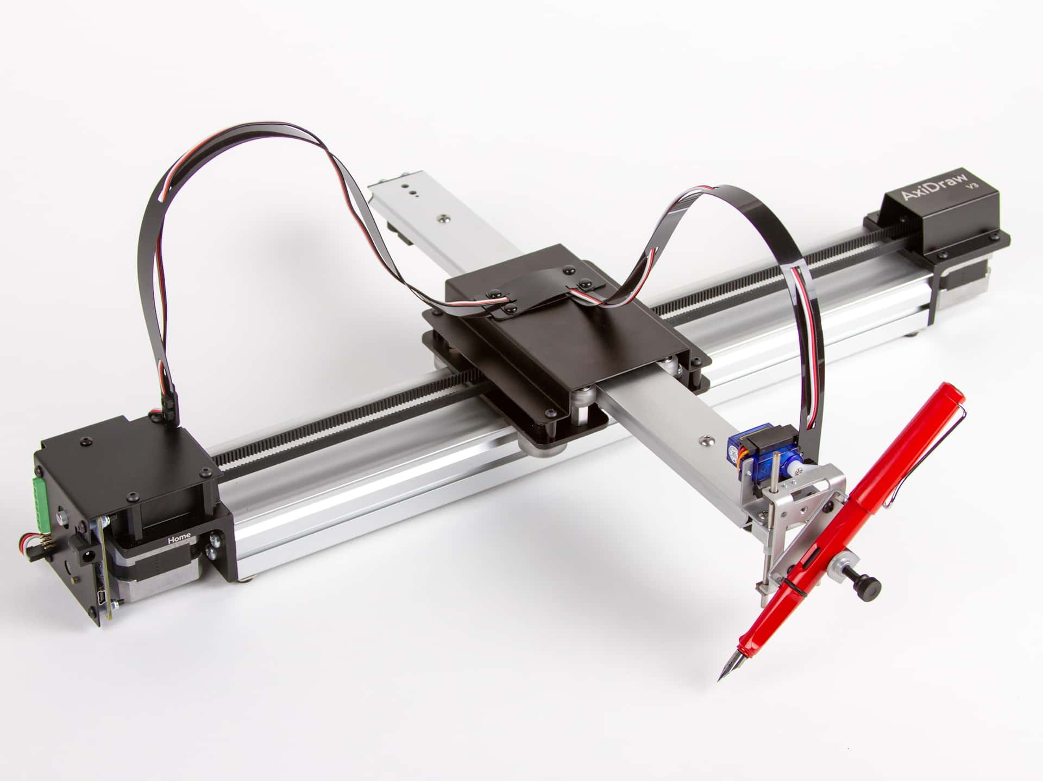

* Pen Plotter:

This [center pivot pen plotter](http://dbynoe.blogspot.ca/2012/09/drawing-machine.html) is an interesting take on the idea, and manages to somewhat simplify the fabrication when compared to a gantry-style built. Normally we’d see a gantry that travels on two rails, with a print head that moves along its length.

Here the gantry is anchored on just one side, with a chain driven system to rotate it along the plotting surface. The print head uses a fine-point felt-tipped marker. It still travels along the arm as you would expect, and can be tilted away from the paper for repositioning.

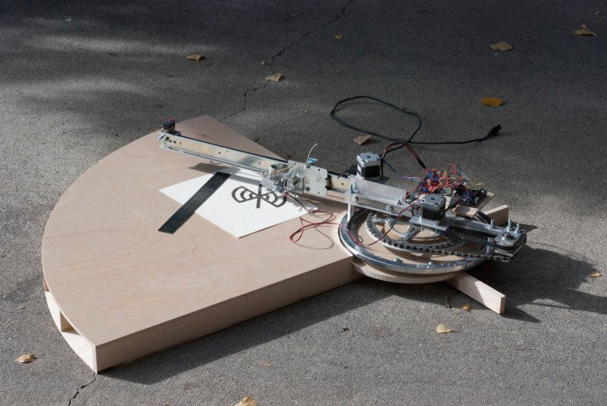

* Makelangelo:

**The Makelangelo is an art robot that draws posters and murals. It’s a fun, easy, and affordable way to learn about 3D printing CNC technology without the burning hot danger nozzle or the expensive, tricky plastic.**

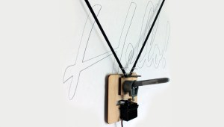

1. Observe in local market, online market, and various labs of the college and in and around your locality to find out relevant hints and ideas which can be helpful for your project. List out at least 5 such observations, for each observation give a brief description with images.

* Crazy Engineer’s Drawing Bot:

Link: <https://arnabkumardas.com/cnc.html>

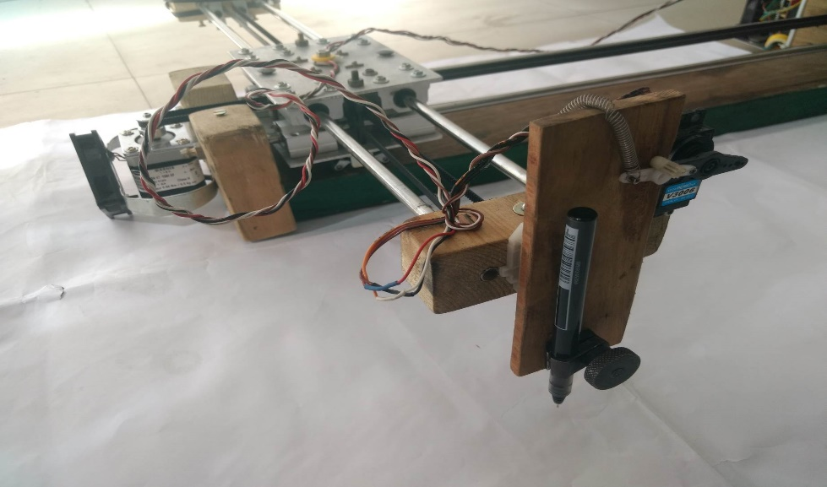

1. Calculate cost estimation for the existing solution.

The cost estimated will be around Rs1000 – Rs4000.